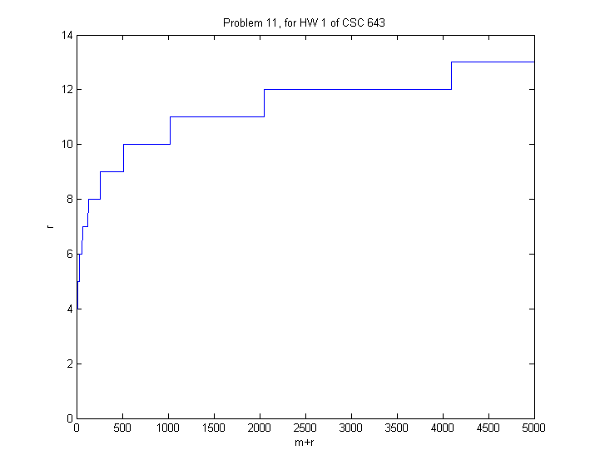

function [] = Redunant_bits(n)

m = 0;

r = 1;

x = [];

y = [];

while( m+r <= n)

r = get_r(m,r);

y = [y; r];

x = [x; m+r];

m = m+1;

end

plot(x, y, '-');

xlabel('m+r');ylabel('r');

title('Problem 11, for HW 1 of CSC 643');

end

function [r_return] = get_r(m,r)

if(2^r >= m+r+1)

r_return = r;

else

r_return = r+1;

end

end